Curriculum Vita
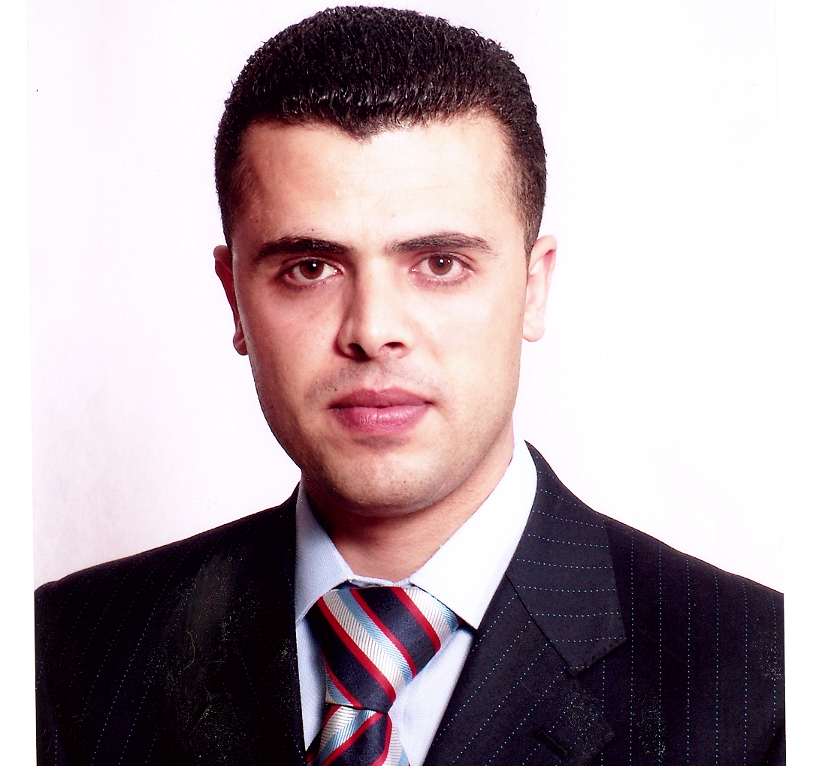

Personal Data:
Name: Saher Ibrahim Taradeh
Birth date: 1.5.1979
Nationality: Palestinian
Position: Faculty Member- Al-Quds Open University
Marital status: Married
Address: Palestine- West Bank-Hebron
Tel: 00972-2211459 mobile: 059-7142266
E-mail: staradi@qou.edu

Qualification and Certificates:
- Post graduate: Master in Computer Information System/ Arab Academy for Banking and Financial Sciences 2005.
- Graduation: B.Sc. in Information Systems / Palestine Polytechnic University 2001.

Working Experience:
- I am working in Al-Quds Open University as instructor since 4/2005.
- I am working in Palestine Polytechnic University as part-time instructor.
- I worked in Al-Quds Open University as computer technician of Yatta Study Center from 3/2002 to 4/2005.

Researches and papers
- "Incremental Inductive Learning Algorithm (I-ILA)" 13th International Arab Conference in Information Technology (ACIT’2012), Jordan, 10-13/12/2012
- Paper "Analyzing Stakeholders and there Relation to the Strategic Planning for Taffouh 2011-2014" Taffouh , 14/5/2011
- Book Auditing " E-Commerce"
- Book Auditing "Introduction to Computer"
- Scientific arbitration of educational Media "Electronic Payment methods"
- Educational media "Arrays in C Languages"
- E-Course design "Information System Management"
- Questions Bank "Information System Management"

Conferences and Workshops:
- Workshop "Preparing the Questions for Questions Bank" Ramalla 21/11/2011
- Workshop "Developing Blended Learning Courses" Ramalla 6/12/2011
- Workshop "Design the Electronic Content" Ramalla 27/12/2011
- Workshop " Evaluation criteria Rubrics" Ramalla 6/12/2011
- Workshop “scholarships, Language Examination and Study in UK” British Council and Al-Quds Open University, Dura 16/3/2011
- Conference on "Computer and Information Technology" Palestine Polytechnic University, Hebron, Palestine, 9 march 2010.
- Conference on "2nd Information and Communication Technology Day", Ramallah, Palestine, 4 march 2008.
- Conference on "Palestinian Universities, Struggle and Development", Ramallah, Palestine, 20 May 2007.
- Conference on "Quality, Excellence, Accreditation in Higher Education Institutions", Al-Quds University, Jerusalem, 25-26 March 2007.
- Workshop on "Distance and Open Education", Hebron, Palestine, 22 March 2007
- Workshop on "Developing the Quality of Examination in Al-Quds Open University", Hebron, Palestine, 11 July 2005.
- Conference on "Information and Communication Technology", Ramallah, Palestine, 12 November 2005.
- Conference on "The Scientific Research Reality and the Horizons of its Development in Al-Quds Open University", Ramallah, Palestine, 2 October 2005.

Training courses:
- Communication skills in English, Institute of Applied Science and training, 7/12/2010
- LATEX course, Institute of Applied Science and training, 7/12/2010
- English language improvement, Al-Quds Open University, 25 training hour, from 26/12/2007-21/1/2008.
- E-Learning Skills, Al-Quds Open University,
- Multimedia course, Al-Quds Open University, ICTC,
- Certified trainer in Elluminate Virtual Class.
- Training program in “higher Education at a Distance and by E-Learning” in corporation with Manitoba University-Canada, 60 training hour from July 16th – October 10th 2008.
- IC3, 2009

Skills and Interests:
- Systems analysis and design
- E-Learning design
- Programming languages: C, C++, Java
- E-Commerce
Memberships:
- President of Taffouh Association for Higher Education
- Secretary of Palestinian national Assembly of the associations and clubs
- Member of Strategic Planning Committee of Taffouh
References:
- Prof. Younes Amro- President of Al-Quds Open University
- Dr. Noaman Amro- Manager of Hebron Branch- Al-Quds Open University
- Dr.Faisal Khamayseh- Palestine Polytechnic University

Saher Taradeh

