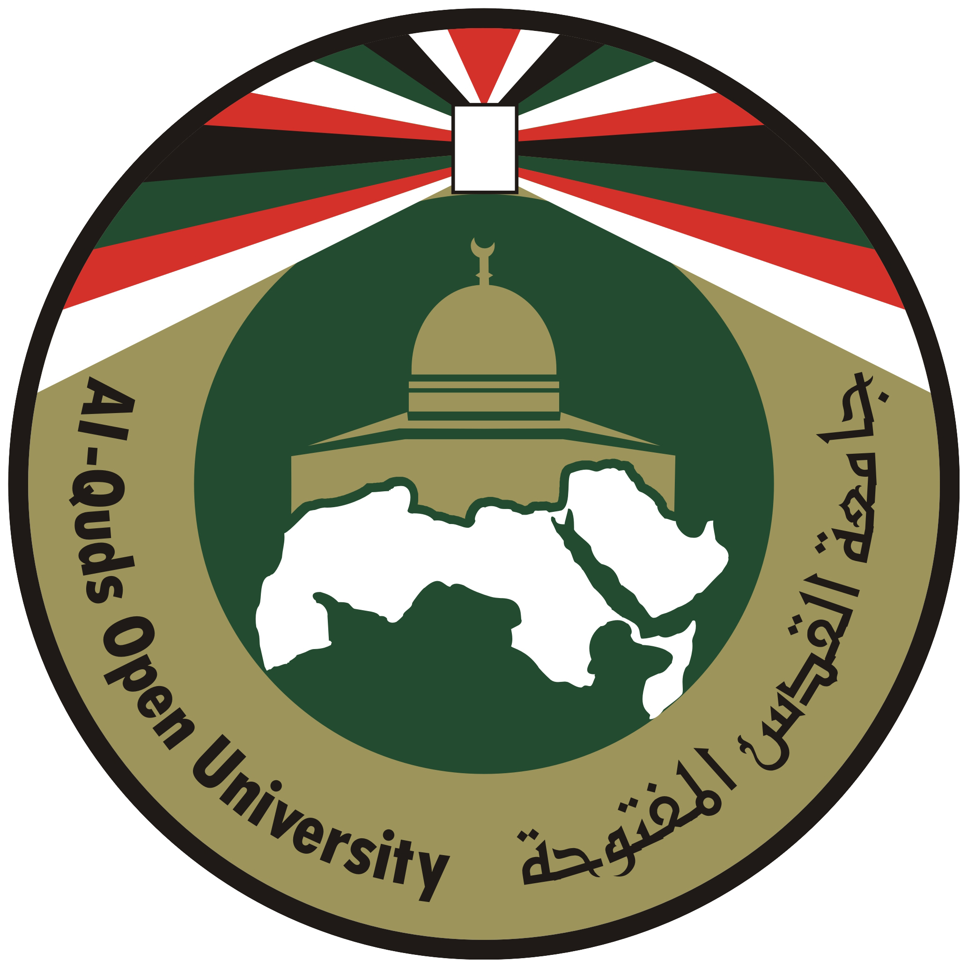

Al-Quds Open Universty
(C.V. Form)

Personal Information

A Abu Qutaish | Deeb | Mohammad | Hisham | Full Name :
 |  | Place of Birth: Immuas | 1-6-1956 | Birth Date:
 | Mobile: 00970-599845437 | Telephone: 2901349009702 | Beitunia , Palestine | Address:
 |  |  | Male | Gender:



Academic Qualifications
B.A. | Higher Diploma |  | Master's Degree |  | Ph.D
University of Aleppo | Birzeit University |  | Birzeit University |  |  | Name of University
English Language & Literature | Education |  | English Education |  |  | Specialization
1975-1979 | 1991-1994 |  | 1994-1998 |  |  | Period of Study
Aleppo-Syria | Birzeit |  | Birzeit |  |  | Place of Study
Title of Master's Degree: The Effects of Authentic and Simplified Texts on Palestinian 12th Graders' Reading Comprehension and Processing Strategies.
Professional Experience
Service Period |  | Job Title |  | Institution's Address |  |  | Name of Institution
1999- Till now |  | Academic Supervisor |  | Ramallah Educational Region |  |  | Al-Quds Open University
1998-1999 |  | Researcher's Assistant |  | Ramallah- Al-Masioun |  |  | Al-Quds Open University
1981-1998 |  | Instructor of English |  | Abu Deis |  |  | Arab Jordanian Institute
1980-1981 |  | Teacher of English |  | Birzeit |  |  | Al-Majedah Waseelah Sec. Girls' School



Research, Publications and Prizes
Publication Date | Publication Place | Publisher | Title | No.
1999 | Palestine | Palestinian's Writer's Union | A collection of Short Stories | 1-
1980-2000 | Palestine | Al-Quds Daily Newspaper & other local periodicals | A number of educational articles | 2-
1980-2003 | Palestine | Local newspapers and magazines | A number of short stories | 3-
2012 | Palestine | Al-Quds Daily Newspaper and Maan Electronic Website | A number of short stories, literary texts and educational articles | 4-



Languages
Writing |  |  | Reading |  |  | Speaking |  |  | Language
Excellent | Good | Fairly Good | Excellent | Good | Fairly Good | Excellent | Good | Fairly Good | Language
✓ |  |  | ✓ |  |  | ✓ |  |  | English
 |  | ✓ |  |  | ✓ |  |  | ✓ | French
 |  | ✓ |  |  | ✓ |  |  | ✓ | Hebrew

Affiliation and Activities
I am the president of the board of directors of Teacher’s Creativity Center. I have been holding this position for the last four years. Teacher’s Creativity Center is an NGO interested in education, democracy, human rights and gender.
Our center deals with teachers, students and other educationalists within the above mentioned fields.


Translation Experience

1- Translating from Arabic into English and vice versa for six months in the Palestinian Ministerial Reform Unit. 2004
2- Translating from Arabic into English and vice versa for QOU website for three months. 2005
3- Translating from Arabic into English and vice versa a number of articles and essays for different people and institutions.
4- Translating from Arabic into English and vice versa for the Department of Quality Control and Quality Assurance at AL-Quds Open University.



Fields of Work

- Giving training courses in English in the four language skills: listening, speaking, reading and writing.
- Giving training courses in English for specific purposes.
- Translating from Arabic into English and vice versa.

